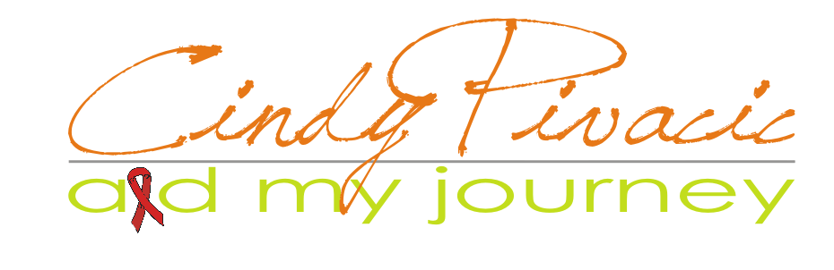

WOMEN’S WELLNESS BREAKFAST

Prepared for

Prepared by
Cindy Pivacic, AID My Journey - Support

P.O. Box 763, Pinetown, 3600
KwaZulu Natal, South Africa

Email: cindy@cindypivacic.co.za
Website: http://www.cindypivacic.co.za

Submitted on
July 2013

Statement of Confidentiality & Non-disclosure

This document contains propriety and confidential information. All data submitted to Dr L Pienaar is provided in reliance upon its consent not to use or disclose any information contained herein except in the context of its business dealings with AID My Journey-Support. The recipient of this document agrees to inform present and any future employees of Dr L Pienaar who view or have access to its contents of its confidential nature.

The recipient agrees to instruct each employee not to disclose any information concerning this document to others except to the extent those matters are generally known to, and is available for use by, the public. The recipient also agrees not to duplicate, distribute, or permit others to duplicate or distribute any material contained herein without AID My Journey-Support’s express written consent.

AID My Journey-Support retains all title, ownership and intellectual property rights to the material and trademarks contained herein, including supporting documentation, files, marketing material and multimedia.

BY ACCEPTANCE OF THIS DOCUMENT, THE RECIPIENT AGREES TO BE BOUND BY THE FOREMENTIONED STATEMENT.

Introduction

AID My Journey-Support is hosting a Women’s Wellness Breakfast on the 29th June 2013 in order to inform, inspire and motivate women by providing life skills that promote positive values and healthy habits – resulting in real life power.

The talks on this day will be structured to encourage women to take control of their Health and Wellbeing as well as empower them to positively influence the lives of their loved ones and the community around them.

The main speaker is Cindy Pivacic, founder and CEO of AID My Journey-support. Cindy will talk about her belief that the HIV and AIDS issue is getting steadily worse due to the lack of knowledge, education and not wanting to acknowledge that there is still an enormous problem.

Cindy is living proof that a healthy lifestyle can prolong your existence if you have prior knowledge of what to do, where to go, when and how to do it. This makes her speaking relevant and personal and designed to be both educational as well as motivational.

Two guest speakers, Antoinette Zeelie (GNLD) and Rachelle Baxter (Curves), will also share some motivation on the day.

The topic of the event is: “Dare to care – a better me...”

If you feel your products and/or services speak to the heart of a women and fit into this type of environment, keep reading...

Event Details

The aim of the event is for women to come and enjoy a relaxed morning of friendship, food and inspirational guest speakers while enjoying a nice breakfast.

You could take part in the event by exhibiting and selling your products and/or services before and after the event. Exhibitors are also welcome to be a guest at the event.

The Event:
Date: 1st August 2013
Time: 8 for 8:30am – 10:30
Venue: Augusta Country Estate, Hillcrest
Theme: “Dare to care – a better me...”

Exhibitors RSVP by 18 June 2013 by emailing your confirmation to karinvanniekerk01@gmail.com .

The Running Order for the day (subject to change):

- 8:00 – 8:30 Guests arrive (guest registration & exhibition active)
- 8:35 Opening and Welcoming
- 8:40 Breakfast is served
- 8:55 Speaker 1: Rachelle Baxter (Curves)
- 9:10 Speaker 2: Antoinette Zeelie (GNLD)
- 9:25 Coffee break & prize draw
- 9:35 Main speaker: Cindy Pivacic
- 10:30 Networking and/or guests leave
Exhibitor Set-up Details

In order to book a stand at the event, exhibitors should confirm their booking via email and make payment before 18 June 2013. Tables and table cloths will be made available the day before the event (26 June 2013).

Please ensure to either set-up the day before or at least early enough before the guest arrive on the day of the event. Available set-up times and more information regarding the set-up will be shared upon agreement of this proposal.

Exhibitors could exhibit as well as attend the breakfast as a guest.

Marketing Opportunity

Exhibitors have an opportunity to sponsor a prize for the prize draw or samples/gifts which will be included in the Gift Bags which each of the guests will receive by the end of the event.

In return the exhibitor could include a flyer/brochure to advertise products or services into the Guest Gift Bag or enjoy a discount* on the exhibition stand. Please contact the Event Organiser to discuss the best suitable option.

Cost Breakdown and Payment Details

1 x Exhibition stand only R250
1 x Breakfast ticket only R220
1 x Stand + 1 x breakfast ticket R420
1 x Table of 10 @ R220 per person, free exhibition stand included.

*A suitable discount could be considered upon sponsoring of gifts or prizes. Please contact the Event Organiser to discuss the possible options.

Confirmation
Please confirm before 18 June 2013 whether you will be taking part in this event as an exhibitor and/or sponsor.

Information and Contact Details
For more information regarding this event please contact Karin van Niekerk on 082 457 3476 or karinvanniekerk01@gmail.com .

For more information about AID My Journey-Support, please contact Cindy Pivacic on 073 739 6044 or cindy@cindypivacic.co.za . Alternatively please visit the AID My Journey website www.cindypivacic.co.za .

