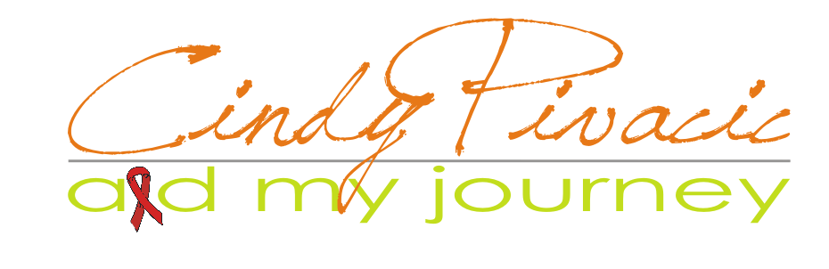

POSITIVE LIVING

Prepared for

Prepared by
Cindy Pivacic, AID My Journey

P.O. Box 763, Pinetown, 3600
KwaZulu Natal, South Africa

Email: cindy@cindypivacic.co.za
Website: http://www.cindypivacic.co.za

Submitted
March 2011

March 2012

Pinetown, KwaZulu Natal, 3610

Dear Sir/Madam

Thank you for your interest and consideration for support.

The objective in recently founding AID My Journey-Support is to play a major role in the transformation of how HIV and AIDS is managed, providing valuable structured programmes on HIV and AIDS and programmes used to enhance employers and employees:

“Educate and empower people by providing local life skills programmes that promotes positive values, healthy habits, and education – resulting in real life power.”

A priority need for the HIV and AIDS programme, which operates daily, is funding for supplies and part-time program staff. In the past, my contribution has been mainly voluntary work.

AID My Journey-Support is requesting financial assistance to support a program that makes a meaningful difference in the lives of the beneficiaries. An ongoing contribution will give AID My Journey the jumpstart required while continuing to implement alternative plans.

I believe that the HIV/AIDS programme is consistent with the mission and interest of the target market vital to public needs, and hope that you will find it in your budget to support this program. If I can provide additional information to encourage consideration of this request, please feel free to contact me. I would also be happy to present this proposal to your committee.

Most sincerely,

Regards

Cindy

Cell: 073 73 96 044
Fax: 086 56 46 935
P.O. Box 763
Pinetown
3600

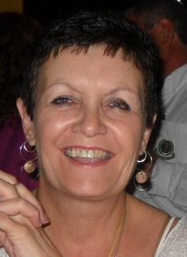

Email: cindy@cindypivacic.co.za
Website: www.cindypivacic.co.za

Skype: cindy.pivacic

Facebook Business Page: Cindy Pivacic – Speaker
http://www.facebook.com/pages/Cindy-Pivacic-Speaker/
125107450888545?v=info

Enclosure: Program Funding Proposal

Statement of Confidentiality & Non-disclosure

This document contains propriety and confidential information. All data submitted is provided in reliance upon its consent not to use or disclose any information contained herein except in the context of its business dealings with AID My Journey-Support. The recipient of this document agrees to inform present and any future employees who view or have access to its contents of its confidential nature.

The recipient agrees to instruct each employee not to disclose any information concerning this document to others except to the extent those matters are generally known to, and is available for use by, the public. The recipient also agrees not to duplicate, distribute, or permit others to duplicate or distribute any material contained herein without AID My Journey-Support’s express written consent.

AID My Journey retains all title, ownership and intellectual property rights to the material and trademarks contained herein, including supporting documentation, files, marketing material and multimedia.

BY ACCEPTANCE OF THIS DOCUMENT, THE RECIPIENT AGREES TO BE BOUND BY THE FOREMENTIONED STATEMENT.

Request for Funding Proposal

ORGANISATION AND MISSION

In 2011, AID My Journey-Support, established as the sole objective of targeting the English speaking public with the purpose of providing an expert service to the community at large.

A comprehensive program of HIV and AIDS education, support, physical, educational and life skills necessary to prepare, promote and empower the beneficiaries in their communities to make their lives a success.

The rate of increase in HIV prevalence has seemingly slowed down, the country is still to experience reversal of these trends. There are still many people living with HIV/AIDS, many are still being infected or
affected on a daily basis. The impact on individuals and household levels are enormous and will affect the country’s ability to realise the targets for 2015.

AIDS has been cited as the major cause of premature deaths, maternal and childhood mortality are amongst the highest, threatening the most devastating effects of HIV and AIDS in the country.
With mortality rates increasing about (79%) in the period (1997 -2004) with a much higher increase in women than men, children are a particularly vulnerable group with high rates of mother-to-child transmission as well as the impacts of ill health and death of parents, with AIDS contributing 50% to the problem of orphans in the country.

The South African HIV and AIDS epidemic has the ability to propagate on its own if unchecked.

Whilst the immediate determinant of the spread of HIV relates to behaviours such as unprotected sexual intercourse, multiple sexual partnerships, and some biological factors such as sexually transmitted infection, the fundamental drivers of this epidemic in South Africa are the deep-rooted institutional problems. Poverty, underdevelopment and the low status of women, including gender-based violence in society is also finding its quiet way into the higher echelons of the public of South Africa.

COMMUNITY NEED

It was not too many years ago, that KwaZulu Natal earned its reputation as a tough community to survive with many of the same problems faced by similar communities. We heard too many reports about, rape, substance abuse, teen pregnancy, as well as academic failure related to HIV and AIDS. All that is changing, and AID My Journey-Support is a key element in the transformation. There is a tremendous need, especially for high-risk, low-income beneficiaries, for programmes that provide tutors and mentors in a safe, confidential environment instead of seeing throngs of people unable to support themselves. AID My Journey–Support is giving them hope for the future.

SOLUTION

Until the early 1990’s the scene described above would not have been imaginable in KwaZulu Natal. With the population KwaZulu Natal boasts, very little safe, confidential, and thorough HIV and AIDS programmes. However, AID My Journey-Support based in Pinetown, operates an HIV and AIDS programme, providing assistance and mentoring that promote life skills and character development through ongoing support necessary to beneficiaries.

PROJECT DESCRIPTION

Teaching high-risk communities the skills to become self sufficient, aware and responsible for their health and wellness.

The HIV and AIDS programme major components of the programme are:

- Nutrition education to promote healthy lifestyles and combat infection
- Life skills, which are integrated throughout all phases of the program
- Physical wellness
- The individual counselling programme – instruction, health and life skills education
- The support program (Support Group) awareness, health and life skills education 2 hours/month
  - Beneficiaries receive counselling in one-on-one sessions
  - They learn about attitudes, self-esteem, taking responsibility for choices, and management of their health and wellness.
- These life skills integrated throughout the programme, and counselling routinely demonstrates how they apply to situations in all aspects of life.
- Nutrition and healthy lifestyles are stressed both in the individual and group settings.
- The program is fortunate to have a corps of volunteers who are dedicated to the programme and are available to work with the beneficiaries on improving their health.
- An active role taken in this area used to work individually with the beneficiaries using current health and wellness programmes.
- Videos used to improve comprehension.

POPULATION REACH PLAN 2011

- Youth 15-18 years old (Schools) – 5000

In addition low/medium/high income:
Female, Male Adults:
- Caucasian
- Indian
- African
- Other

OUTCOMES AND EVALUATION

At least 100% of participants will complete program as measured by attendance
At least 80% of participants will demonstrate improvement as measured by quarterly reports, counsellor progress reports, and tutor feedback.
At least 60% of participants families will increase there knowledge and family support.

PARTNERS

AID My Journey-Support strongly believes that the formula for providing effective, cost-efficient
in addition, high quality programmes includes collaboration with many community organisations.
AID My Journey collaborates with the following groups:

- SASOHN (South African Society of Occupational Health Nursing) identifies beneficiaries for the programs within the corporate sector.
- Lay Counsellors - serve as volunteer tutors and mentors
- Interns – serve as volunteer tutors and mentors
- AID My Journey provides curriculum for life skills
- Schools
- Youth Groups - Churches

SUSTAINABILITY OF PROJECT

To serve eligible beneficiaries, virtually all of whom are unable to pay for services, AID My Journey-Support is developing a fund raising plan, which includes initiating an annual fund drive targeted to individuals.
An annual ‘Black Tie’ event; funding requests to area civic clubs, organisations; and corporate CSR funding.

PUBLICITY

AID My Journey-Support will be pleased to acknowledge your contribution with appropriate recognition at speaking engagements. In addition, we would make mention of your gift in our newsletter and submit news releases to local newspapers.

REQUEST

AID My Journey-Support requests a monthly contribution to initiate and develop the HIV and AIDS Programme that will make a meaningful difference in the lives of our area’s beneficiaries and help create a safer community.

BUDGET INFORMATION

Expenditures:

Salaries R 13, 000.00
Advertising/promotion R 500.00
Equipment & other capital expenses R 1,000.00
Printing & publications R 1000.00
Rent & other occupancy costs R 4,000.00
Supplies/Sundries Other expenses R 500.00
Telephone/Website R 1200.00
Travel (fuel/maintenance) R 1,500.00

TOTAL EXPENDITURES R 22,700.00

FINANCIAL PROSPECT GOAL

Revenue:
Self-sustaining by publishing my book ‘AID My Journey’ R 150.00 per book
Remunerated for speaking engagements R 2 000.00 per 1hr talk or part thereof
CSR (Corporate Social Responsibility) funding as per corporate structure

Cindy

Regards
Cindy Pivacic
AID My Journey

FNB – Westville
Account Name AID My Journey Support
Account Type Cheque Account - (non-profit)
Account Number 6233 080 2712
Universal Br Code 250655

ABSA
Account Name AID My Journey-Support
Account Type Savings - (non-profit)
Account Number 9266 809 550
Branch Code 632005 (Pinetown)

